**Zenoir Online Classroom**

**User’s Manual**

**System Overview**

Zenoir Online Classroom is an E-learning system which is mainly targeted towards teachers and students to implement online learning. The importance of these kinds of software is that it encourages the participation of students in the classroom this is implemented in the sessions module of the system which emulates classroom discussions in the real world.

The system is composed of two modules, the administrator module and the classroom module. The administrator module is mainly used for managing user accounts, courses, subjects and classrooms. The classroom module is mainly used by the teachers and students for their online interactions such as participating in online discussions, submitting assignments, downloading handouts, and sending messages to other users in the classroom.

**Tech Stack**

Here are the set of technologies and tools that I have used in the development of this system:

* CodeIgniter
* jQuery
* jQuery UI
* DataTables
* HTML KickStart
* jScrollPane
* Node.js
* Now.js
* Socket.io
* Git

**Administrator Module**

In this section I’ll walk you through the administrator module. The administrator module is mainly used for managing user accounts, courses, subjects and classrooms. New user accounts, subjects, courses and classes can only be created in this module. This is also where the system administrator can enable or disable existing classrooms.

Below is a screenshot of the administrator module. Buttons which links to users, subjects, classes and courses are all accessible from the administrator’s home page.

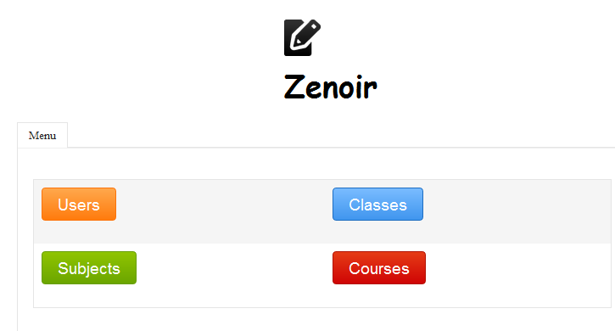

**Users**

Let’s first head on to the users. This is where you will find a list of all the people in all the different classrooms.

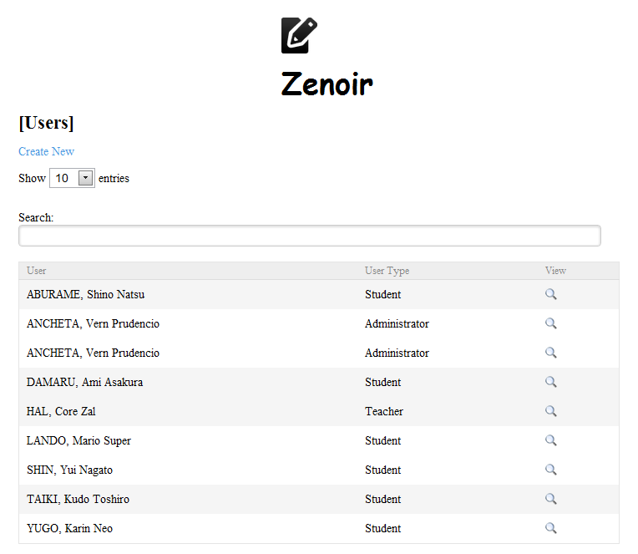

Clicking on the view icon will let you view the activity log for the user that you have selected. Only the activities performed by the students and teachers are being logged by the system so viewing another administrator’s log will show nothing.

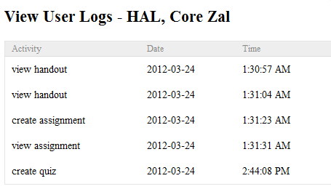

New users can also be created. An administrator can create a student, teacher, or another administrator. The password for the user is not included since the user id and the password is the same by default the user has to change it on first login.

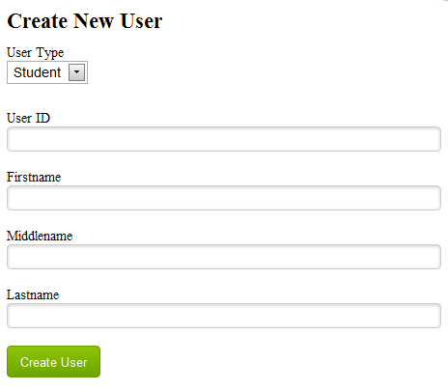

**Subjects**

This is where you can create and manage subjects. Subjects are just like what they are in the real world; some examples would be Math, Science, Biology, etc. These are the actual subjects being taught by teachers. This will later on be associated with a class that will be created.

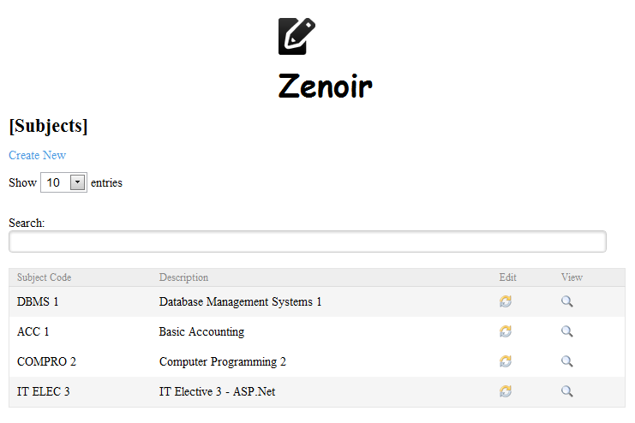

New subjects can be created by clicking on the Create New link.

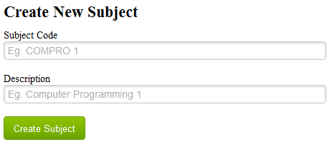

**Courses**

This is where you can create and manage courses. This is a college student specific feature but it is required. If you’re using this software for elementary or high school students you can have a course description like Elementary Students or High School Students.

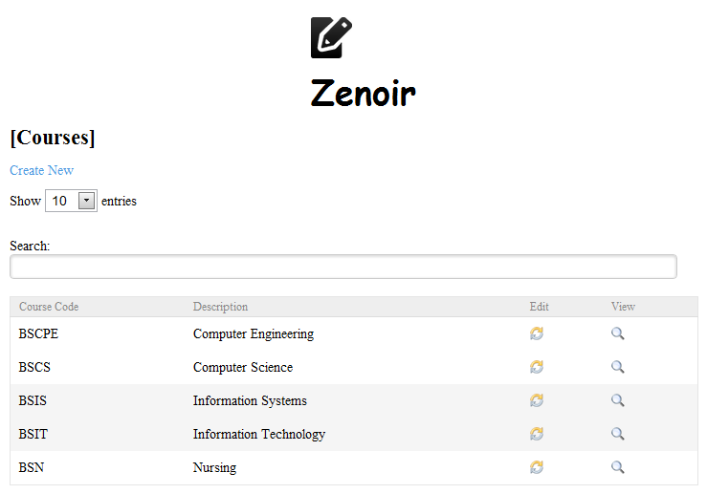

Creating new courses is as easy as creating new subjects.

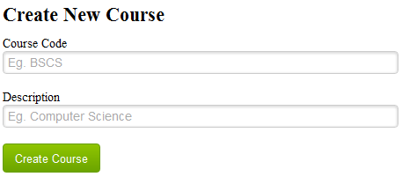

**Classes**

Classes are the actual classes that are being attended by each teacher and student in a real world setting. Teacher A can have a class on biology with the 1st year college BSIT Students, but can also have another class on biology with the 1st year college BSN Students those two are both classes in biology but they’re with a different set of people so each of those are considered two different classes.

I guess the example was good enough so let’s go back to the system. You can see here the list of existing classrooms. Information such as the class code description, subject and teacher is indicated. You can actually type any search term on the search box, for example if you only want to see classes in Accounting you just need to type Accounting and all the classes in accounting will be listed on the table. Clicking the view icon will allow you to enter the specific classroom but it’s strictly for viewing purposes only, you as the administrator can only view things inside the classroom. Participating in classroom activities is possible but is not encouraged since the administrator’s role does not cover it.

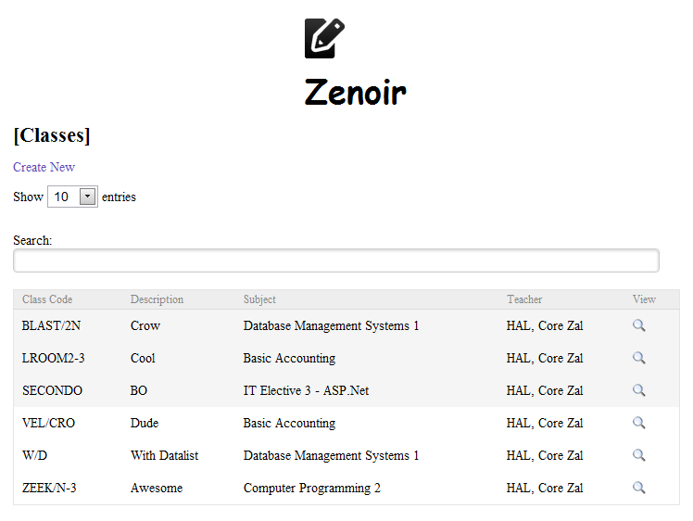

Creating a new class requires subject, teacher, and course information. You actually need to create entries for the subject, teacher and course before creating a new class. The class code is a unique representation of a class. There is a naming convention for class codes which composed of the subject code + slash separator + course code + year. If there are multiple sections in a course then you can also include the specific section to make the class code unique. The start and lock dates is the range of dates when the class will be accessible by both teachers and students. After the lock date the classroom will automatically be disabled, but the teacher can later on request the administrator to enable the classroom so that the students can still continually access it even if the formal class is already over.

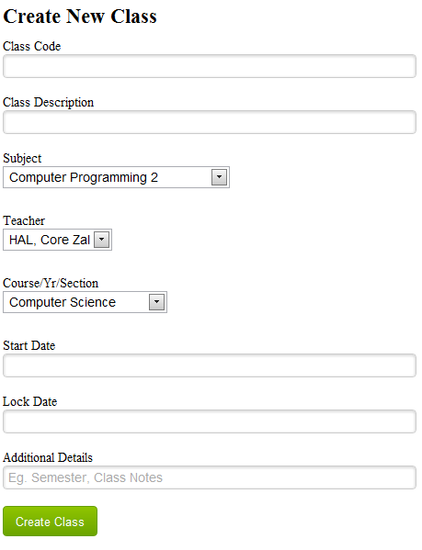

**Classroom Module**

The classroom module is the main meat of the system. This is where the teacher and students can interact with each other in an online environment. Below is a screenshot taken from a student account. Information such as the class code, class description, teacher and additional classroom details can be seen on every page that is under this module.

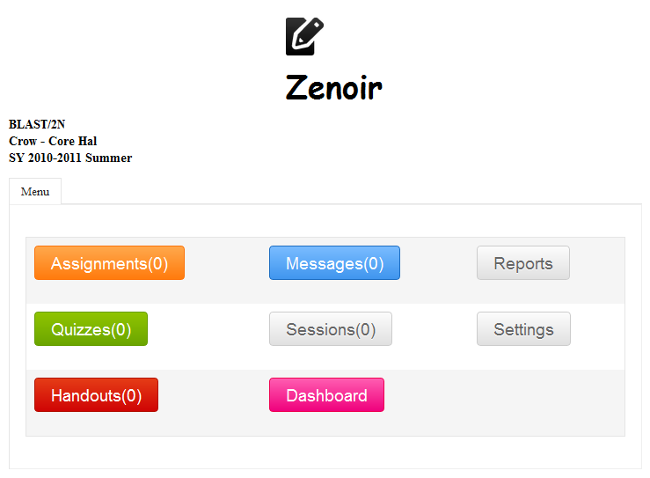

**Dashboard**

When you first log in the first thing that you will see is the dashboard or the landing page. This is where you will see a list of class that you can currently access, invites to a particular classroom, unread posts from all the classrooms that you are part of, and the previous classes that you have attended to. The dashboard is where you can find all the information relevant to your account.

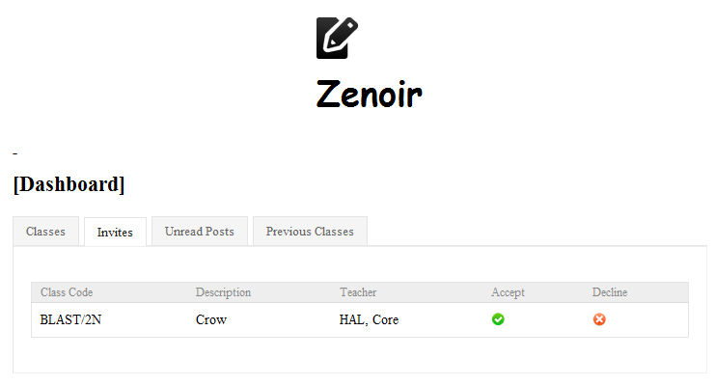

**Assignments**

This is where you as the teacher can create new assignments for the students to submit later. In creating new assignments the teacher can also attach files that is related to that particular assignment. The students can submit the assignment as long as the date in the server is less than or equal to the current date.

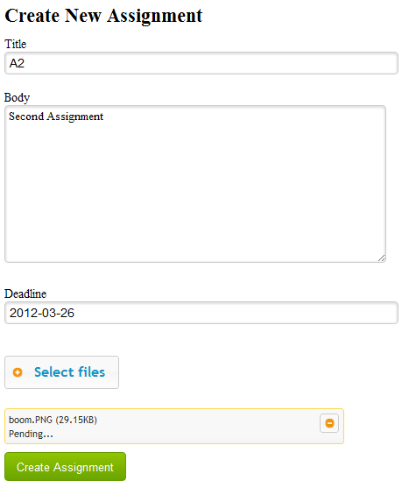

You can also view the responses to a particular assignment by clicking on the view response button.

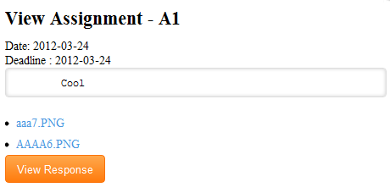

Clicking the View Response button will show a list of the names of the students and the corresponding date and time in which the reply was submitted. The red star indicates that the reply hasn’t been read by the teacher yet.

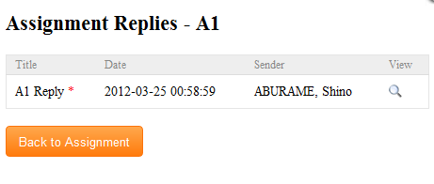

Clicking the view icon will show the details of the response.

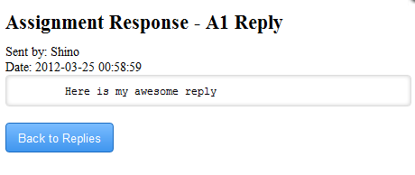

Existing assignments are all listed.

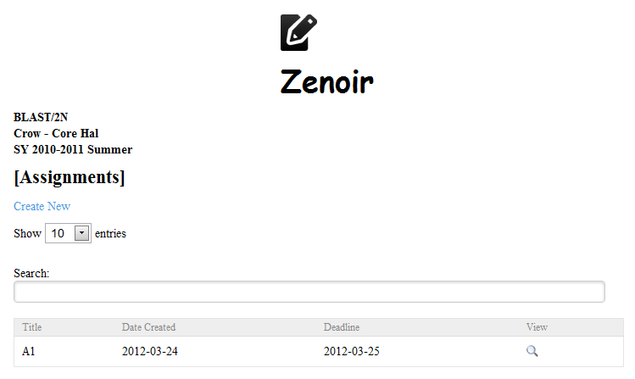

**Messages**

This is where the students and teachers can interact inside the classroom in a private manner. This is very useful in cases wherein the student has problems which he cannot open to the whole class. The messages can also be used on things that aren’t classroom related that is why the activities here aren’t logged in the database.

Creating a new message involves selecting the people who will receive the message, the title and body and also the files if there is any. Only people who also belongs to the classroom that you are currently logged in are listed in the select box.

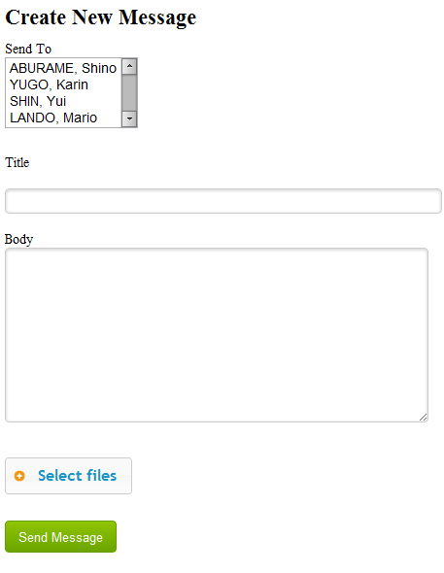

The list of messages are divided into two categories, the inbox where the messages sent to you are listed and the outbox where the messages that you have sent out to other people are listed. You can view any message by clicking on the view icon.

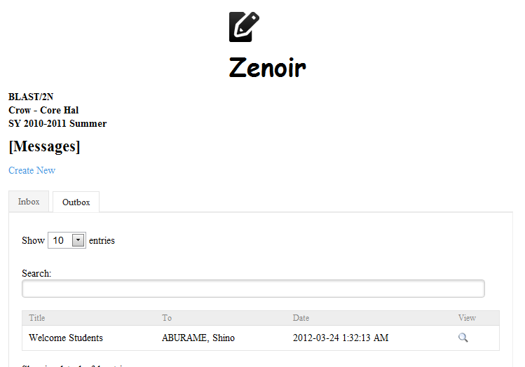

**Reports**

The reports is where you can view student-related information such as the autobiography and user activity log.

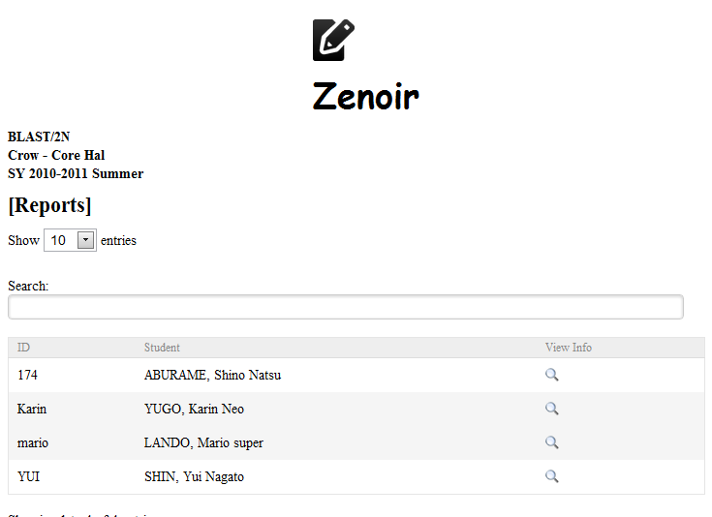

Clicking on the view icon opens up a new model window that allows you to view the students autobiography.

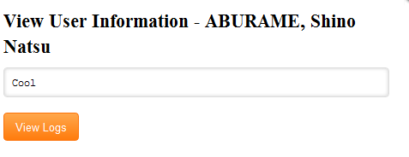

Clicking the View Logs button shows a list of all the activities performed by the student in the classroom along with the date and time when it was performed. This is very useful if the teacher wants to track what the student is actually doing inside the classroom.

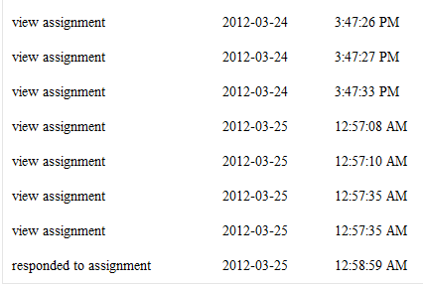

**Quizzes**

This is where you can create new quizzes. Quizzes are only multiple choice type at this time but I’m planning to add other types of quizzes in the future versions of this system.

Quizzes has a start and end time, this is the range of time upon which the student can take the quiz. Accessing the quiz before or after the allotted time isn’t allowed by the system. Quizzes should also be taken by the students after opening because it can only be opened once.

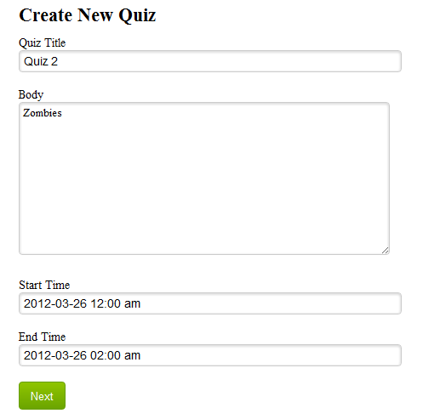

After entering the general details of the quiz, the quiz items is then set. First you have to enter the number of items in the quiz and then input the question, the four choices and lastly the answer to the question.

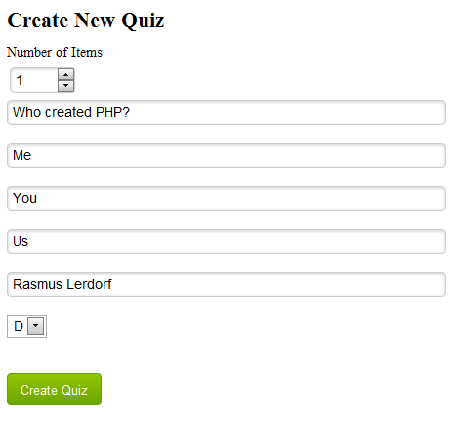

Clicking on the Create Quiz button will create the quiz. It will immediately be listed in the table of existing quizzes.

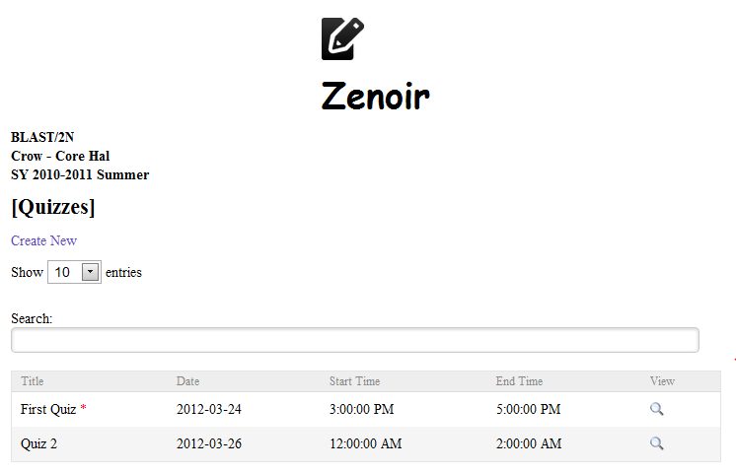

Clicking on the view icon shows all the details pertaining to the quiz. And that includes the quiz items.

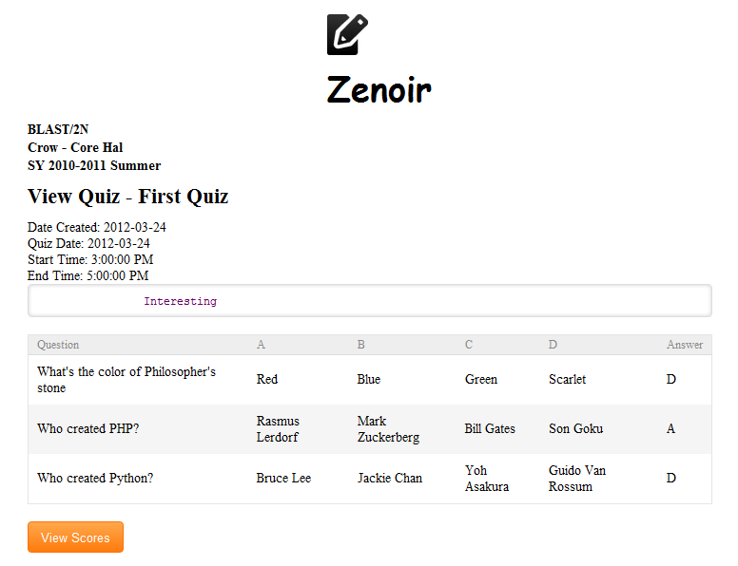

Clicking the View Scores will allow you to view the scores made by each student.

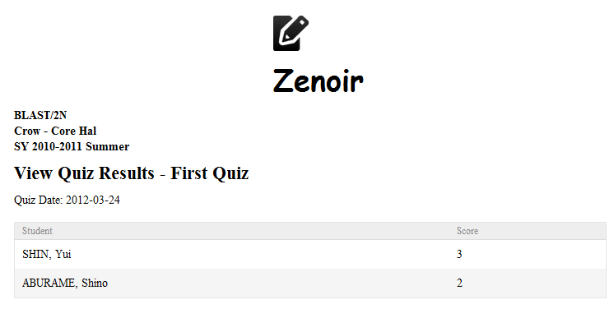

**Handouts**

The handouts is where you can post useful resources, links, documents related to the class.

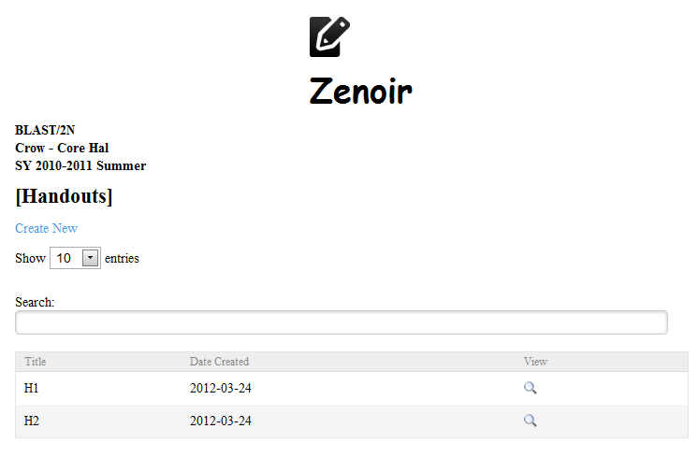

Creating a new handout is simple, you just have to input the title, body and upload some files.

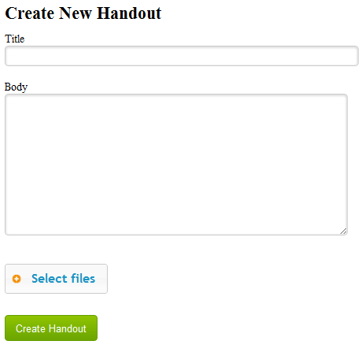

**Sessions**

This is the main meat of the classroom module. This is where the teachers and students can interact with each other in real-time. This is merely an emulation of the discussions made in a classroom in the real-world but it encourages participation from each of the students. This will mainly benefit the shy-type students who aren’t participating in classroom discussions mainly because they’re afraid of raising their hands and are too nervous to answer questions personally.

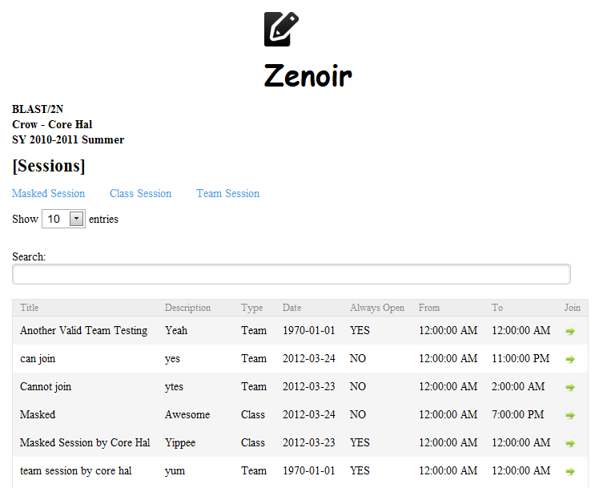

There are 3 types of sessions:

* Class Session – can only be created by teacher and all members of the class are automatically members of a class session.
* Masked Session – the same with the class session the only difference is that the members have the option to use an alias upon joining the session. This is very useful in cases wherein the topic for the session requires opinions and ideas which aren’t very pleasant when the opinion or idea is associated to a real person’s name.
* Team Session – members of this session can be selected by the creator of the session.

Creating a new session requires the title, description, accessibility status, and the range of time upon which the session is accessible. If the always accessible checkbox is checked the session will always be accessible, members of the session can post anything anytime because the session never expires members can continuously pour some ideas and opinions. If the always accessible checkbox is not checked then you have to input the time from which the session is accessible and also the time in which it will expire. Expired sessions can still be seen on the list but cannot be entered by anyone anymore.

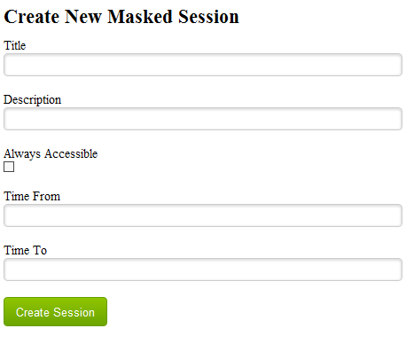

When you are late in entering a session you will not be able to see previous messages that were sent before you joined in the main chat box but you can view it by clicking on the history link, this outputs the conversations before you joined the session.

**Settings**

This is where you can control the settings in the classroom. You can invite existing students from other classrooms, remove existing students from your class, enable or disable specific modules, and export classroom data to other classes that you also handle.

First on the list is inviting students from other classes. This lists all of the students that are not currently part of the classroom where you are currently logged in.

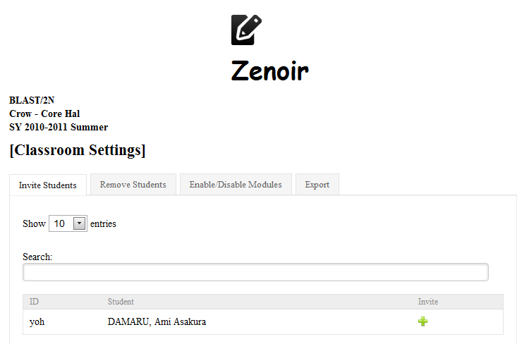

Clicking on the add icon will prompt you if you want to invite the student into the class.

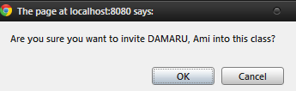

Clicking OK does not automatically add the student into the classroom the student has to confirm the invitation first before he can be a member of the class.

Next is the removing of students in the classroom. This is where you can remove students who are currently a member of the class where you are currently logged in.

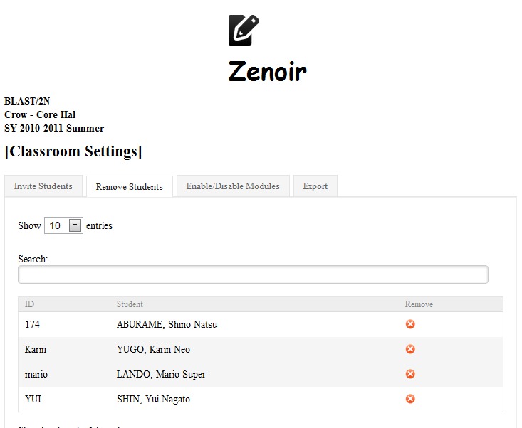

Next is the enabling and disabling specific modules in the classroom. All you need to do here is to check the modules that you want to enable and uncheck the modules that you want to disable. All the modules are enabled by default. Once disabled the students and you as the teacher will not be able to access the module. This is useful in cases wherein you have to limit what the students can do inside the classroom.

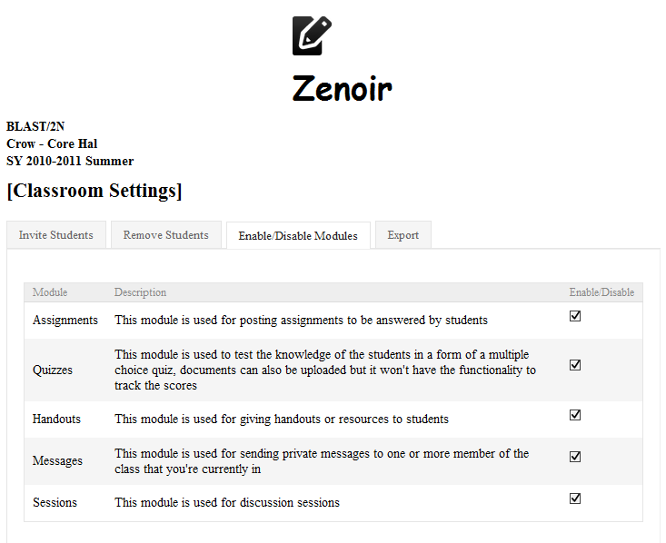

Lastly there is the classroom export feature. This is where you can take the data from the classroom where you are currently logged in and transfer it into the other classes that you handle. All you have to do here is to check what you want to export (students, handouts or both) and then select the classroom where you want to export it and then click on the export button.

